**Step 1:** **search** for load balancer in the portal and click Create

**Step 2:** Create **Standard Internal** Load balancer

Choose the right Resource Group.

Give the Load balancer a Name.

Choose the right region (same as the VMs and Domain controller VM).

Choose **Standard** (not Basic) SKU for production. Basic will retire soon.

Choose **Internal** (not Public) since this is for internal traffic. Finally, CLICK NEXT (Front IP configuration)

**Step 3: Add Front IP** (**this IP will be SQL AG’s Listener IP**)

Give a name to front ip. Choose the subnet of the production nodes. Give static IP. MAKE SURE THE IP is STATIC. SAVE and CLICK NEXT (backend pool)

**Step 4: Add Backend Pool** (this are the 2 prod nodes that will be in the AG)

(the front IP will listen to these backend pool and floats the IP between the two when a failure happens)

Give a name to the backend pool and ADD the VMs

Finally SAVE and Click Next (Load balancing rule – INBOUND RULE)

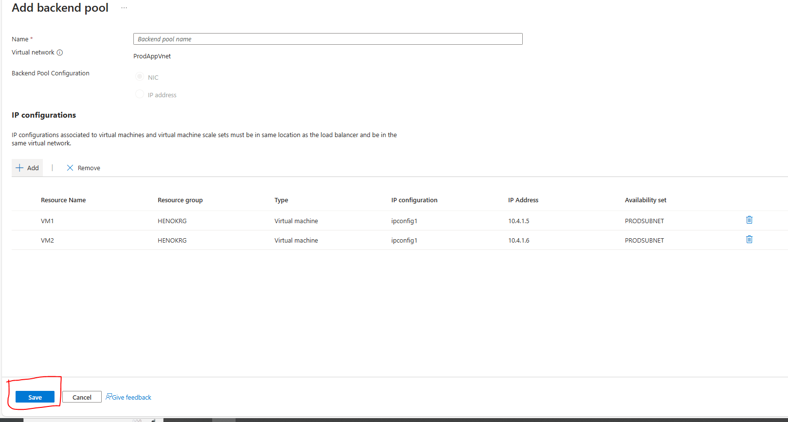

Step 5: INBOUND RULE – Load balancing rule

(this rule

Click add Load balancing rule, not NAT.

Give a name to the rule. IPv4 (default). Choose the Front IP and Backend Pool you created in the previous steps. TCP (default). Add 1433 as Port and Backend Port.

MAKE SURE **ENABLE FLOATING IP is CHECKED** (because the front IP will float between the 2 nodes). If floating ip is not enabled, it will not work.

**Before You hit SAVE and Create Health Probe** (click “Create new” under Health Probe). Health Probe next pic.

Give name to the health probe. Choose TCP protocol. Add Port e.g. 59999. Interval 5 seconds is the default.

Whatever **Port** you used, it should **be ADDED in the FIREWALL RULES** of the VMs. E.g. the 59999 rule should be added.

Now SAVE!

Lastly, no further configuration is needed hit “review and create”. The Load Balancer configuration is finished.

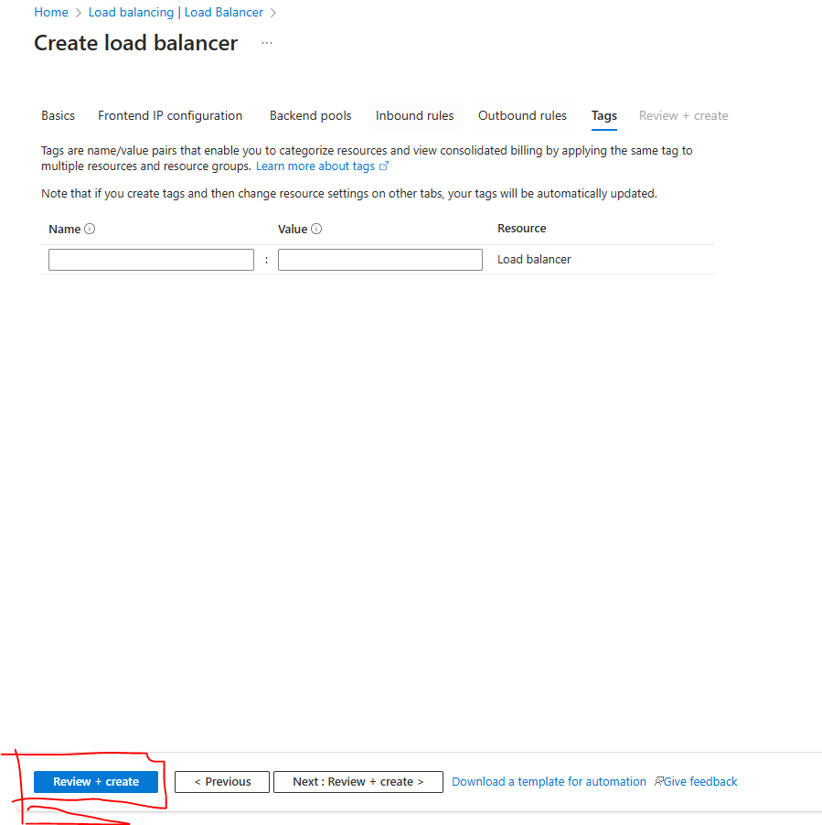

After it is created, you can check the configuration and change the configuration if needed like adding new front ip, remove and add new VMs, new rules…etc

Important reference

[Configure an Azure load balancer for an AG VNN listener - SQL Server on Azure VMs | Microsoft Learn](https://learn.microsoft.com/en-us/azure/azure-sql/virtual-machines/windows/availability-group-vnn-azure-load-balancer-configure?view=azuresql&tabs=ilb)